[ Product Data Sheet ]

Digital Signage

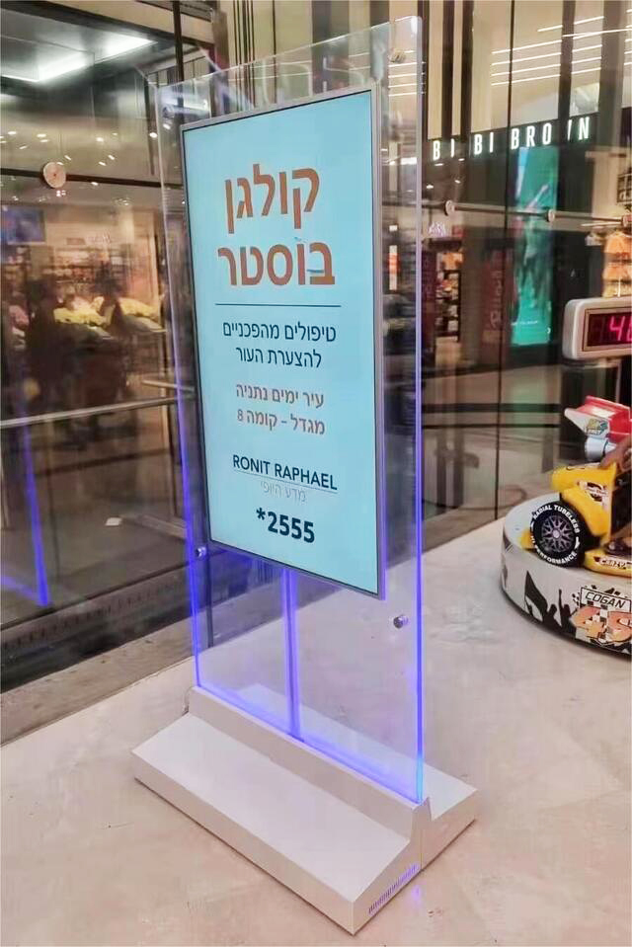
49 Inch – Floor Standing - Double-Sided Display

Specification Parameters:
Product Picture | 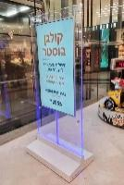 | Model No.: HBM-49EG2-D
Panel Parameters | Panel size | 49”
Panel Parameters | Display Area | 604(H) x 1074(V)
Panel Parameters | Display Mode | 16:9/9:16
Panel Parameters | LCD Type | LCD panel
Panel Parameters | Max Resolution | 1920*1080
Panel Parameters | Display Color | 16.7M
Panel Parameters | Brightness | 450 cd / m2
Panel Parameters | Contrast | ＞5000: 1
Panel Parameters | Viewing Angle | 178°(H) / 178°(V), (CR≥10)
Panel Parameters | Response Time | 8ms
Panel Parameters | Field Frequency | 60Hz
Panel Parameters | Color System | PAL/NTSC
Panel Parameters | OSD Language | Chinese, English
System Configuration | OS | Android 11
System Configuration | CPU/CPU | ARM Cortex A55 RK3568
System Configuration | RAM | 2G
System Configuration | ROM | 16G
Playback format | Video Formats | wmv avi flv rm mvd mpeg ts mp4
Playback format | Audio Formats | mp3, wav, wma, aac, 3gp
Playback format | Image Formats | bmp, jpeg, png, gif
Interface | HMDI | 0
Interface | Ethernet | RJ45 10M/100M
Interface | USB | 2
Audio System | Speaker | 8Ω 10W*2
Power | Input Voltage | AC100V~240V,50/60HZ
Power | Maximum Power | ≤150W
Power | Standby Power | ＜1W
Working Environment | Operating Temperature | 0°C-50°C
Material | Frame Material | Iron and tempered glass
Weight | Machine Net Weight | 68kg

Dimensional Drawing：
(unit: mm)
