55-inch hanging double-sided poster screen specification book-ultra-thin Android version
- product features
HBM-55EG6 Vertical double-sided poster screen is our new ultra-thin all-in-one machine products. The product features are described as follows:
- Market mainstream professional Android Android scheme design, good heat dissipation, stable performance, simple maintenance.
- Bright screen, 1080P HD resolution, ultra-wide perspective LCD panel, to avoid the perspective blind area of ordinary similar products on the market, and further improve the display effect.
- The product uses ultra-narrow frame, ultra-thin body, the whole machine thickness is only 20mm;
- The double-sided screen synchronous display screen, customers can receive the visual impact of the video and pictures brought by the information release at the same time, to increase the attraction and publicity of mobile customers and potential customers;
- Abandon the traditional poster replacement trouble, no video, monotonous pictures of the traditional passive reception of publicity, bring more intense publicity effect;
- Network cable and power cable concealed wiring design, the overall appearance effect is better;
- In the system design, adhering to the stability of the signage series products and advanced, to give customers as always management experience.
- product appearance
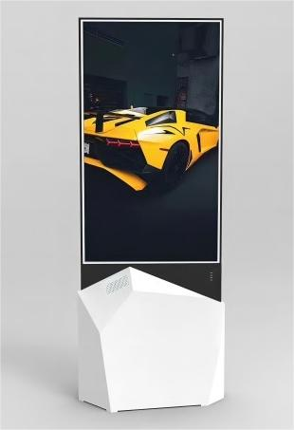 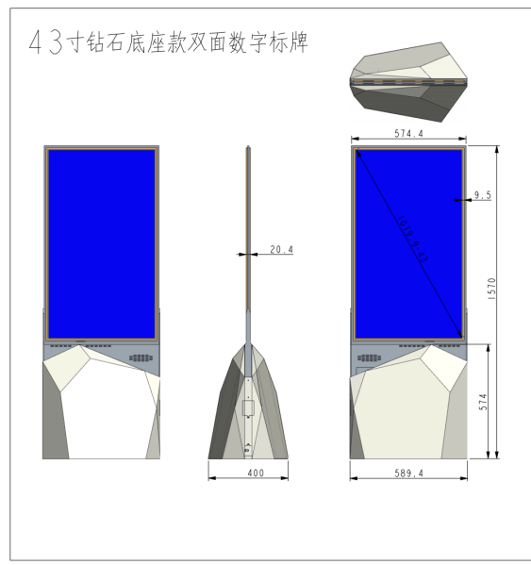

1. | The company is independent of these external appearance, has applied for the appearance patent
2. | All-aluminum backplane is used for self-cooling, and the three sides of the fuselage (left / right / below) are open for heat dissipation
3. | Complete machine: length 905mm width 500mm height 2042mm
4. | Bottom extension of USB * 2, infrared remote control * 1 power interface

Display screen main indicators
The highest resolution |  | 19201080 is displayed line by line
Perspective (CR> 10) |  | 178 (horizontal); 178 (vertical)
pigment |  | 16.7M Colour
luminance |  | Conventional brightness screen 23 sides> 430 cd / m2  Specific highlighting A> 430 cd/m2 B> 700 cd / m2 (price)
contrast ratio |  | ＞1400: 1
Signal response time |  | ＜8ms
Visual area |  | 574.4(H )×996(V )
Backlit form |  | LED
LCD panel screen brand |  | LG
Backlight life |  | For> 50,000 hours
Android configuration
CPU |  | Android quad-core at 1.8GHz and above
GPU |  | GPU Mail-T764
internal storage RAM |  | 2G (optional 2G)
memory ROM |  | 16G (3 optional 32 G)
External extended storage |  | TF card (maximum support up to 128G)
peripheral interface |  | USB×2 、R J45×1
Ethernet |  | Support for 10 / 100M
Wifi |  | Supports wifi 802.11 b / g / n 2.4GHz
telecontroller |  | Support infrared remote control
software configuration
operating system |  | Android 13.0
basic software |  | Web browsing, web chat, email, ebook, resource manager, clock, alarm clock, calculator, recording, etc
functional characteristics |  | Remote software controls the timing switching machine
 |  | Dual screen display, inside and outside the screen can respectively play different content
 |  | Dual screen separate control, the internal and external screen can define the timing switch of different periods, such as the inner screen can be shut down at 18:00 after work, the outer screen can still be played externally, if it can be set to 21:00 timing shutdown.
 |  | Real-time remote monitoring, 7 * 24 hours unattended
 |  | Support for landscape screen, portrait screen automatic configuration
 |  | Support for wireless screen projection (optional)
 |  | Support remote upgrade
functional parameter
Supported video formats: |  | Support for AVI (H.264、DIVX、XVID）, rm，rmvb， MKV（H.264、DIVX、DIVX、XVID），WMV，MOV，MP4 （H.264、MPEG、DIVX、XVID）, FLV（H.263，H.264), TS, 3GP, MPG, and many other formats
Supported image formats: |  | BMP, JPEG, PNG, GIF and other conventional formats
Support for audio formats: |  | MP3, WAV, WMA, AAC and 3GP
volume |  | The management platform is adjustable
Automatic timing on and off |  | support
Play mode |  | Cycle playback, slot, timing, timing and other playback modes
Electrical indicators and product dimensions
Power specifications |  | Input voltage range: AC100V to 240V
The horn power |  | 5W×2
maximum power dissipation |  | ≤250W
Standby power consumption |  | ≤1W
working temperature |  | 0℃～40℃
Working humidity |  | 10% to 90%, with no condensation
Storage temperature |  | -20℃～60℃
Appearance size |  | Length 905mm width 520mm height 2068mm
way to install |  | Vertical screen landing
Complete machine net weight |  | 35KG
appendix
instructions | A set of oneself
Remote control / battery | A set of oneself
Wifi antenna | 1 Endyceps root
power line | 1 Endyceps root
Lifting accessories | A set of oneself

product appearance

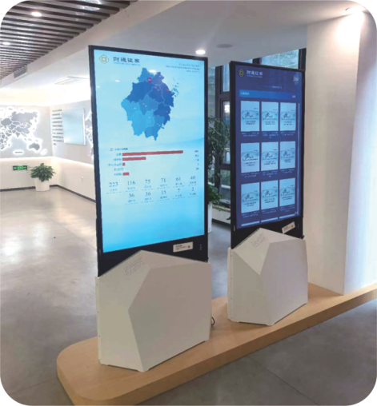

Software description:

Plain material delete, renamed, preview of the function material upload, new folder, copy, paste, copy, delete, search, drag the material to the folder and other functions

Support for different material types (picture, background, video, music, word, excel, ppt, PDF, web page, streaming, apk, button)
Template import / export, all / cancel all, single / multiple, share / cancel share function
Production page:
The setting function of template screening, template search and template production popup in the program production page
Program scene:
1. Add, delete, copy, and scene length setting functions of the main scene
1. Functions of sub-scene addition, deletion, copy, and scene duration setting
Add jump:
1. Add the function of jump to picture, video, scene, web page jump, jump back time
Set the jump (touch):
1. Set the function of jump, including the addition, delete, replacement, drag and other functions
2. The functions of the previous, next, home page, add, delete, edit, close, double-click exit, swipe left and right, turn left and right, turn left and right, slide up and down, and so on
Set up the jump:
1. Set the function of jump, including the addition, delete, replacement, drag and other functions
2. The functions of the previous, next, home page, add, delete, edit, close, double-click exit, swipe left and right, turn left and right, turn left and right, slide up and down, and so on
Box selection alignment:
Box selection function of left alignment, horizontal center, upper alignment, right alignment, vertical center, bottom alignment, horizontal distribution, and vertical distribution
Control right-click property:
1. Control delete jump, add jump, copy, paste, spread full, delete, put the top layer, put the bottom layer, the last layer, the next layer function
2. Right-click attributes of control elements including text, pictures, video, music, word, excel, ppt, PDF, mix, weather, date, countdown, web page, streaming media, exchange rate dynamics, stock dynamics, apk, signal source and so on
Release Settings:
1. Control and broadcast priority function of ordinary programs, interrupted programs, exclusive programs and gasket programs
2. Functions of program broadcast date, terminal selection, saving, submission and release
3. Mechanism tree, selection, search and condition filtering of the device selection interface
Program search, sort, edit, release, delete, view details, preview, paging and other functions, in the editing, can repeat the content of the program production 3.1-3.10
Release progress statistics of the pop-up interface
Specifies the terminal to delete programs
In the production play plan page, the plan name of the play plan, the setting of the play date, the program addition (including the program search, paging, sorting, preview, selection, etc.), the addition of the play time period, the drag, save, the next step, etc
Features of the message save, next step, message name, message type, message content, message type, message type, playback speed, start time, end time, font size, font color, background color, background transparency
Search, searching, sorting, editing, publishing, deleting, viewing details, preview, paging and other functions
On the pending review page, the message search, sorting, audit, paging, list display function
On the audited page, message search, sorting, details, paging, list display function

