22 inch holographic transparent screen specification book

Model：DY-220G01
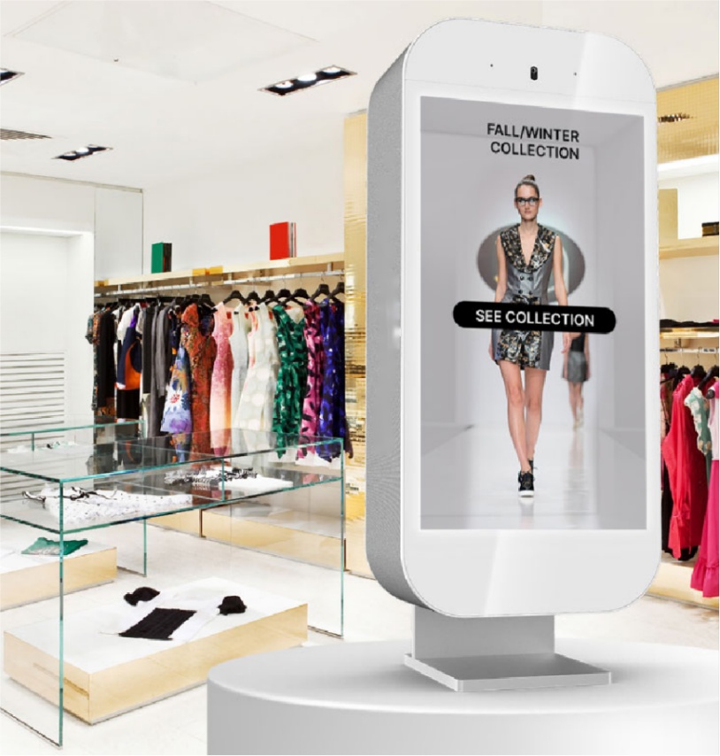
一、Product Introduction:
The HBM-220G01 transparent screen adopts an IPS screen, supporting ultra high definition 1920 * 1080 resolution, with delicate images and high resolution, smooth video playback, and includes audio and video processing functions, which can output high-quality images and sound quality. High brightness, super wide viewing angle, high color gamut, High color depth and fast response time display effect. Industrial grade design, advanced technology for energy conservation and environmental protection.
二、Functional features:
Adopting IPS hard screen technology, with a large viewing angle, fast response speed, and high color reproduction;
The display screen adopts a-Si TFT-LCD, which provides a more perfect display;
1920 * 1080 ultra high resolution, with finer image quality performance;
The panel protection adopts 3mm ultra white crystal tempered glass with a hardness of ≥ 6H;
Adopting nano capacitor touch, making operation more convenient and perfect;
The viewing angle can reach 89/89/89/89 (Min.) (CR ≥ 10), approaching the level;
The entire machine is made of all metal structure, which is anti radiation, anti magnetic field, and anti strong electrical interference;
Industrial grade design, high reliability and stability
三、Specification parameters：
Product Reference Drawing | 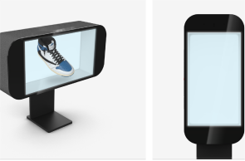 | size：22”  model: HBM-220G01
Panel Parameters | Panel size | 22”
Panel Parameters | Display Area | 476.064(H) × 267.786(V)
Panel Parameters | Display Mode | 16:9/9:16
Panel Parameters | LCD Type | LCD panel
Panel Parameters | Max Resolution | 1920*1080
Panel Parameters | Display Color | 16.7M
Panel Parameters | Bnightness | 300/150 cd / m2
Panel Parameters | Contrast | ≥1200:1
Panel Parameters | Viewing Angle | 89/89/89/89（Min.）(CR≥10)
Panel Parameters | Response Time | 8ms
Panel Parameters | Field Frequency | 60Hz
Panel Parameters | Color System | PAL/NTSC
Panel Parameters | OSD Language | Chinese, English
Touch parameters | Touch Style | Capacitive touch
Touch parameters | Touch Style | 10 touch
Computer Configuration | System | Android
Computer Configuration | CPU | RK3568
Computer Configuration | RAM | 4G
Computer Configuration | ROM | 32G
Playback format | Support video formats | support：wmv avi flv rm mvd mpeg ts mp4
Playback format | Frequency | MP3 WMA
Playback format | Picture | BMP,JPEG,PNG,GIF
Interface | HDMI | 1
Interface | Eternet | RJ45 10M/100M
Interface | USB | 2
 | Audio Sytstem | 4Ω 8W*2
Power | Power | AC100V~240V,50/60HZ
Power | Maximum Power | ＜80W
Power | standby power | ＜1W
work environment | Operating Temperature | 0°C-50°C
Figure | Frame material | Hardware

四、Product Dimensional Drawing：

